**INTRODUCTION**

An enterprise network is the backbone for facilitating an organization’s communications and connecting computers and devices throughout departments. An enterprise network environment is usually configured to facilitate access to data and insight into analytics.

Enterprise networking refers to the physical, virtual and logical design of a network, and how the various software, hardware and protocols work together to transmit data. When it comes to enterprise networking, every organization has different needs, and in the era of digital transformation, modern enterprises are relying more on software-driven solutions to power intelligent network architecture, automation and design.

Security is another major responsibility of enterprise network administrators. Perimeter firewalls and internal firewalls are designed to secure apps and data from outside attacks, and firewall configuration is therefore an essential part of enterprise networking. To improve enterprise network security, security administrators seek advanced methods to scan data packets for viruses and malware to prevent infections that can spread from phishing attacks and etc.

In this project we made a sample network for an enterprise with firewall which has been implemented using cisco packet tracer.

**LITERATURE SURVEY**

|  |  |  |
| --- | --- | --- |
| **Name** | **Publishers** | **Summary** |
| Enterprise Network Design and Implementation using Cisco Packet Tracer | * Aisha Muhammad * Aisha Abdulrahman Abba * Kashim Kyari Mohammed * Abuhuraira Abubakar   Published year: December 2020 | When creating an Enterprise network, divide the network into appropriate areas  Define clear boundaries between each of the areas. |
| Designing Network Design Spaces | * Ilija Radosavovic * Raj Prateek Kosaraju * Ross Girshick * Kaiming He * Piotr Dollar   Published year: 2020 | understanding of network design and discover design principles that generalize across settings. Instead of focusing on designing individual network instances, we design network design spaces that parametrize populations of networks. |
| **Planning, designing and implementing an enterprise network in a developing nation** | * Augustine C. Odinma* * Sergey Butakov * Evgeny Grakhov * Felix Bollou   Published year: 2008 | This paper briefly discusses the architecture of an enterprise network.  It examines the barriers to planning, designing and implementing an enterprise network in some developing nation |

**HARDWARE AND SOFTWARE REQUIREMENTS**

## Hardware –

## Processor –

## AMD Athlon 3000G and above

## Intel i3 4th gen and above

## Ram – 4Gs

## Storage - 240gs SSD / 512gb HHD

## Software –

## Windows 10

## Cisco Packet Tracer

## PROPOSED METHOD

## Justification for using Cisco Packet Tracer:

## Cisco Packet Tracer is a powerful network simulation program that allows us to experiment with network behavior and ask “what if” questions. Packet Tracer provides simulation, visualization, authoring, assessment, and collaboration capabilities to facilitate the teaching and learning of complex network concepts.

## Packet Tracer supplements physical equipment by allowing us to create a network with an almost unlimited number of devices, encouraging practice, discovery, and troubleshooting. The simulation-based learning environment helped us develop 21st century skills such as decision making, creative and critical thinking, and problem solving.

Cisco Packet Tracer has two workspaces—logical and physical. The logical workspace allows users to build logical network topologies by placing, connecting, and clustering virtual network devices. The physical workspace provides a graphical physical dimension of the logical network, giving a sense of scale and placement in how network devices such as routers, switches, and hosts would look in a real environment. The physical view also provides geographic representations of networks, including multiple cities, buildings, and wiring closets.

**ADVANTAGES OF AN ENTERPRISE NETWORK**

Every enterprise needs a unique networking solution that supports the organization’s workflow, production processes, logistics, etc. With the right network, organizations can achieve:

* **Increased efficiency through collaboration:**

Employees can work together on shared resources remotely or in an office, factory, or campus.

* **Controlled access to company's resources:**

Organizations can deliver connectivity to applications and data that’s controlled and secured by perimeter and internal firewalls.

* **Higher productivity:**

From streamlined test/dev with collaboration tools and version control, to private cloud orchestration with cloud-based applications and an agile internal firewall, modern networking can dramatically improve employee productivity.

* **Lower costs:**

The combination of server and network virtualization enables businesses to maximize the efficient allocation of resources across on-premises and cloud infrastructure. Enterprise networking includes solutions for analytics, monitoring, and security that can be installed to further optimize ongoing business operations.

**IMPLEMENTATION**

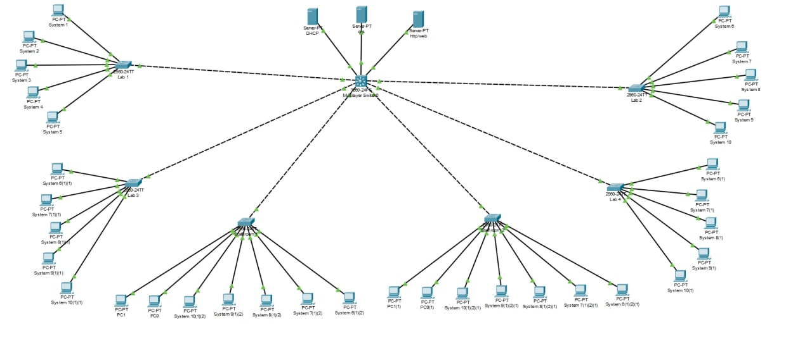

* The above picture depicts our enterprise network connected using star topology where 3 servers mainly webserver, DNS server and DHCP server are connected to a multilayered switch which is connected to six different servers and the servers are connected to different individual nodes.
* We can access the network from any node and search any website registered to the DNS and web server. We can also block any website using firewall.

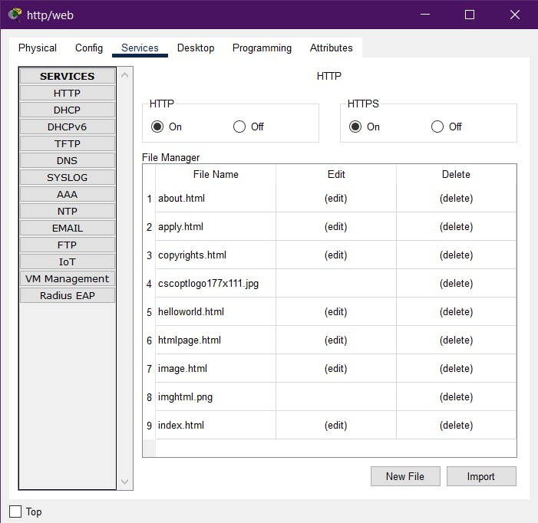

Web Server:

* A web server is a computer that runs websites. It's a computer program that distributes web pages as they are requisitioned. The basic objective of the web server is to store, process and deliver web pages to the users.
* This intercommunication is done using Hypertext Transfer Protocol (HTTP). These web pages are mostly static content that includes HTML documents, images, style sheets, test etc.
* When anyone requests for a website by adding the URL or web address on a web browser’s address bar (for example www.google.com), the browser sends a request to the Internet for viewing the corresponding web page for that address.

Code for index.html:

<!DOCTYPE html>

<html>

<head>

<style>

p{

text-align: center;

font-size:xx-large ;

font-style: italic;

font-family:'Trebuchet MS', 'Lucida Sans Unicode', 'Lucida Grande', 'Lucida Sans', Arial, sans-serif ;

}

p1{

text-align: left;

font-family: Georgia, 'Times New Roman', Times, serif;

}

</style>

<title>JSD Company</title>

</head>

<body>

<p>Welcome to Our Company</p>

<p1><a href="about.html">About</a></p1><tb><br>

<p1><a href="apply.html">Apply here</a></p1><br>

</body>

</html>

Code for about.html:

<!DOCTYPE html>

<html>

<head>

<style>

p{

text-align: left;

font-family: 'Courier New', Courier, monospace;

font-size: medium;

}

h1{

text-align: center;

font-family: 'Courier New', Courier, monospace;

font-size: xx-large;

}

sides{

text-align: left;

font-size: larger;

font-family: Arial, Helvetica, sans-serif;

font-style: oblique;

}

</style>

</head>

<body>

<h1>About us</h1>

<sides>Introduction</sides>

<p>JSD is a global leader in consulting, digital transformation, technology and engineering services. The Group is at the forefront of innovation to address the entire breadth of clients’ opportunities in the evolving world of cloud, digital and platforms.</p>

<sides>Awards and Recognition</sides>

<p>Each year, we are recognized as a global business and IT innovator by our industry partners</p>

<sides>Our Purpose</sides>

<p>Our purpose was developed in collaboration with the Groups many stakeholders, and with its employees at the heart of the process. It now forms one of the fundamentals of the Group.

“Unleashing human energy through technology for an inclusive and sustainable future”: for the Capgemini Group, technology promises progress</p>

</body>

</html>

Code for Apply.html:

<Html>

<head>

<title>

Registration Page

</title>

</head>

<body bgcolor="Lightskyblue">

<br>

<br>

<form>

<label> Firstname </label>

<input type="text" name="firstname" size="15"/> <br> <br>

<label> Middlename: </label>

<input type="text" name="middlename" size="15"/> <br> <br>

<label> Lastname: </label>

<input type="text" name="lastname" size="15"/> <br> <br>

<label>

Course :

</label>

<select>

<option value="Course">Course</option>

<option value="BCA">BCA</option>

<option value="BBA">BBA</option>

<option value="B.Tech">B.Tech</option>

<option value="MBA">MBA</option>

<option value="MCA">MCA</option>

<option value="M.Tech">M.Tech</option>

</select>

<br>

<br>

<label>

Gender :

</label><br>

<input type="radio" name="male"/> Male <br>

<input type="radio" name="female"/> Female <br>

<input type="radio" name="other"/> Other

<br>

<br>

<label>

Phone :

</label>

<input type="text" name="country code" value="+91" size="2"/>

<input type="text" name="phone" size="10"/> <br> <br>

Address

<br>

<textarea cols="80" rows="5" value="address">

</textarea>

<br> <br>

Email:

<input type="email" id="email" name="email"/> <br>

<br> <br>

Password:

<input type="Password" id="pass" name="pass"> <br>

<br> <br>

Re-type password:

<input type="Password" id="repass" name="repass"> <br> <br>

<button onclick="window.location.href='index.html'">

Submit

</button>

</form>

</body>

</html>

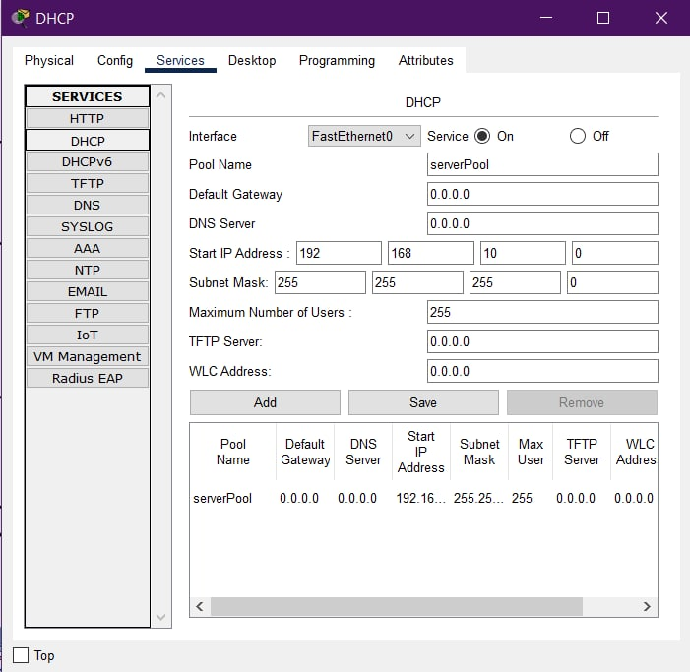

DHCP Server:

* Dynamic Host Configuration Protocol (DHCP) is a network management protocol used to automate the process of configuring devices on IP networks, thus allowing them to use network services such as DNS, NTP, and any communication protocol based on UDP or TCP.
* A DHCP server dynamically assigns an IP address and other network configuration parameters to each device on a network so they can communicate with other IP networks.

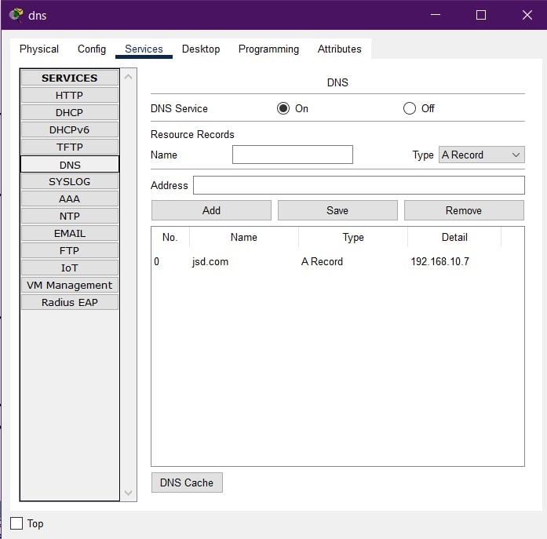

DNS Server:

* The Domain Name System (DNS) is called the phonebook of the Internet. When a user types a domain name or website address into the address bar of the browser, the DNS server is responsible for translating the domain name to a specific IP address, driving it to the correct website.
* A DNS server is a server that manages the domain name system or DNS protocols, matching Internet domain names and IP addresses. The DNS server may also manage domain resolution services.
* In the DNS server, there is a database of domain names, host information, DNS records and network data. The DNS server will search records to return a result. This process allows DNS clients to access the DNS server through a web browser.

**RESULTS DISCUSSION**

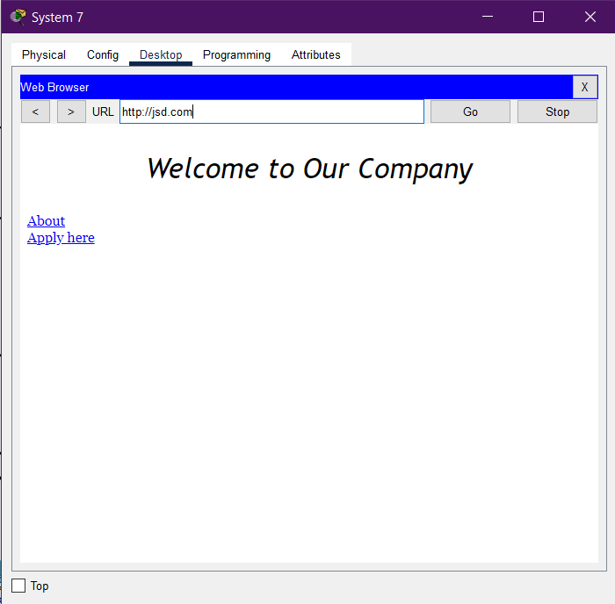

*(Node *System 7* trying to connect to a website)*

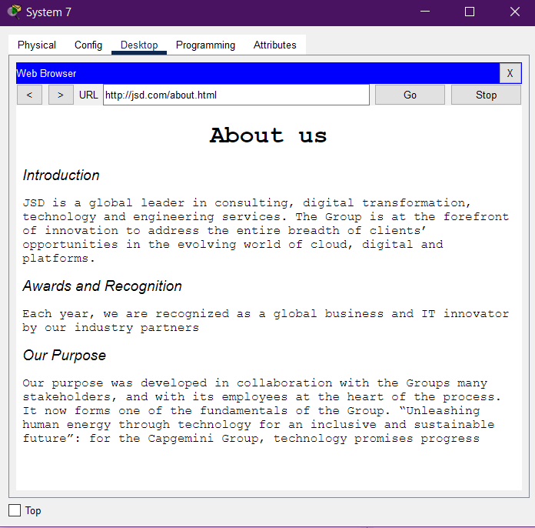

*(Website’s about page)*

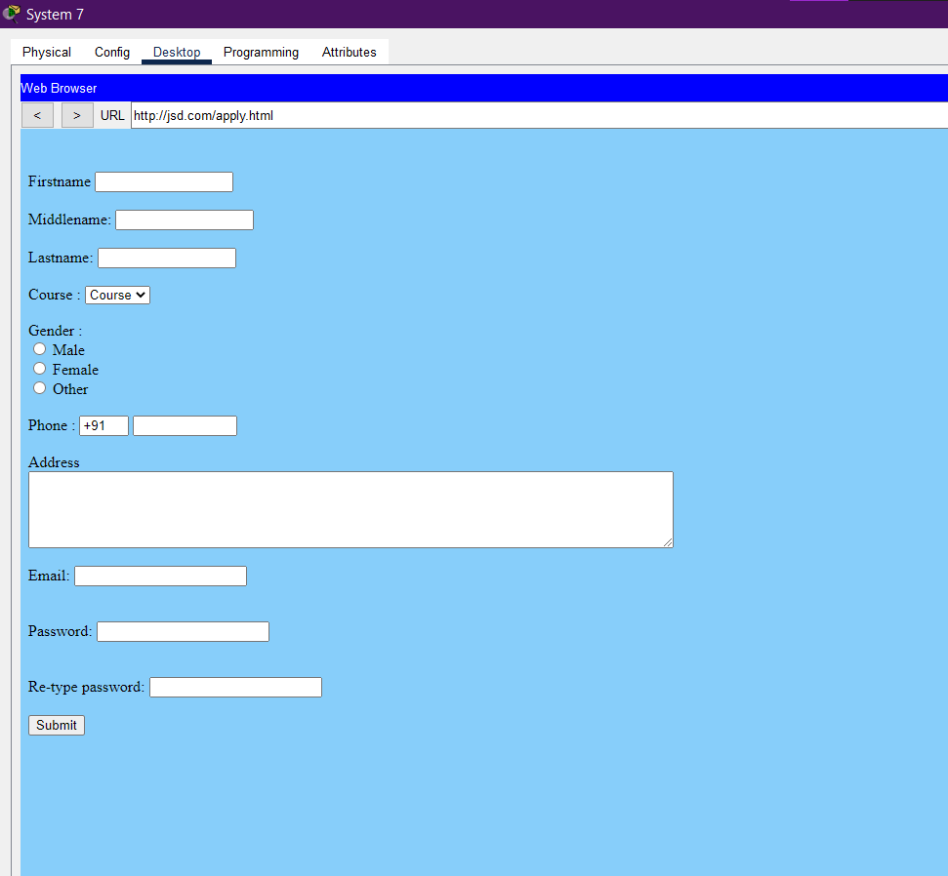

*(Website’s “Apply here” page)*

* In the above pictures you can see that a node is trying to access a website and it’s successful. The site it’s trying to connect is a custom website which introduces itself with “Welcome to our company” phrase where two options are provided(i.e., about and apply page)

**CONCLUSION AND FUTURE WORK**

* The topology of the network is completely functional.
* Multiple LANS are implemented to simulate a real-life enterprise
* Firewall is setup and can be used to restrict any node from accessing the website which is being hosted on a server.
* A website is hosted on the server for an enterprise which can be accessed from all nodes

**REFERENCES**

# **Guidelines for Creating an Enterprise Network**

[**https://www.ccexpert.us/network-design/guidelines-for-creating-an-**](https://www.ccexpert.us/network-design/guidelines-for-creating-an-) **enterprise-network.html**

* **Network Design and Best Practices**

[**https://www.auvik.com/franklyit/blog/network-design-best-practices/**](https://www.auvik.com/franklyit/blog/network-design-best-practices/)

* **How to design an enterprise network**

[**https://www.syscreations.ca/blog/how-to-design-an-enterprise-network/**](https://www.syscreations.ca/blog/how-to-design-an-enterprise-network/)

# **Network Fundamentals** [**https://www.grandmetric.com/training/design-build-enterprise-networks/**](https://www.grandmetric.com/training/design-build-enterprise-networks/)

# **Medium Enterprise Design Profile Reference Guide**

# [**https://www.cisco.com/c/en/us/td/docs/solutions/Enterprise/Medium_Enterprise_Design_Profile/MEDP/chap2.html**](https://www.cisco.com/c/en/us/td/docs/solutions/Enterprise/Medium_Enterprise_Design_Profile/MEDP/chap2.html)